

22f-3104

DB Lab 03



February 16, 2024

FAST CFD campus

**Code:**

namespace _22F_3104_DB_Lab3

{

public partial class Form1 : Form

{

public Form1()

{

InitializeComponent();

}

private void label1_Click(object sender, EventArgs e)

{

MessageBox.Show("Enter your First Name:");

}

private void radioButton1_CheckedChanged(object sender, EventArgs e)

{

if (radioButton3.Checked)

{

string gender = "Male";

}

}

private void label5_Click(object sender, EventArgs e)

{

MessageBox.Show("Confirm Password:");

}

private void textBox1_TextChanged(object sender, EventArgs e)

{

}

private void label2_Click(object sender, EventArgs e)

{

MessageBox.Show("Enter your Last Name:");

}

private void label3_Click(object sender, EventArgs e)

{

MessageBox.Show("Enter your Email:");

}

private void label4_Click(object sender, EventArgs e)

{

MessageBox.Show("Enter your password:");

}

private void radioButton2_CheckedChanged(object sender, EventArgs e)

{

if (radioButton2.Checked)

{

string gender = "Male";

}

}

private void radioButton3_CheckedChanged(object sender, EventArgs e)

{

if (radioButton2.Checked)

{

string gender = "Others";

}

}

private void comboBox1_SelectedIndexChanged(object sender, EventArgs e)

{

}

private void label8_Click(object sender, EventArgs e)

{

}

private void label6_Click(object sender, EventArgs e)

{

}

private void checkBox1_CheckedChanged(object sender, EventArgs e)

{

if (checkBox1.Checked)

{ }

else

{

MessageBox.Show("please check the box!");

}

}

private void button1_Click(object sender, EventArgs e)

{

if (textBox1.Text == "")

{

MessageBox.Show("Please enter your First Name.");

return;

}

else if (textBox2.Text == "")

{

MessageBox.Show("Please enter your Last Name.");

return;

}

else if (textBox3.Text == "")

{

MessageBox.Show("Please enter your Email.");

return;

}

else if (textBox4.Text == "")

{

MessageBox.Show("Please enter your Password.");

return;

}

else if (textBox5.Text == "")

{

MessageBox.Show("Please confirm your Password.");

return;

}

if (textBox4.Text != textBox5.Text)

{

MessageBox.Show("password and Confirm Password do not match");

return;

}

if (!checkBox1.Checked)

{

MessageBox.Show("check on accept the Terms and Conditions.");

return;

}

string gender;

if (radioButton1.Checked)

{

gender = "Female";

}

else if (radioButton2.Checked)

{

gender = "Male";

}

else

{

gender = "Others";

}

string summary = $"First Name is: {textBox1.Text}\n" +$"Last Name is: {textBox2.Text}\n" + $"Email is: {textBox3.Text}\n" + $"Gender is: {gender}\n";

MessageBox.Show(summary, "Details");

}

}

}

**Task no 1:**

1. Open Visual Studio.
2. Create a new Windows Forms Application project.
3. Name the project "RegistrationFormApp."

**Task no 2:**

1. Open the Form Designer.
2. Create a registration form with the following components:
   1. Labels and Textboxes for users to input their:
      1. First Name
      2. Last Name
      3. Email
      4. Password
      5. Confirm Password
   2. Radio buttons for selecting Gender (Male, Female, Other)
   3. A ComboBox for selecting Country (populate it with a few options)
   4. A CheckBox for accepting Terms and Conditions
   5. A "Register" button.
   6. Properly align and space the elements to make the form visually appealing.

**Screen Shot:**

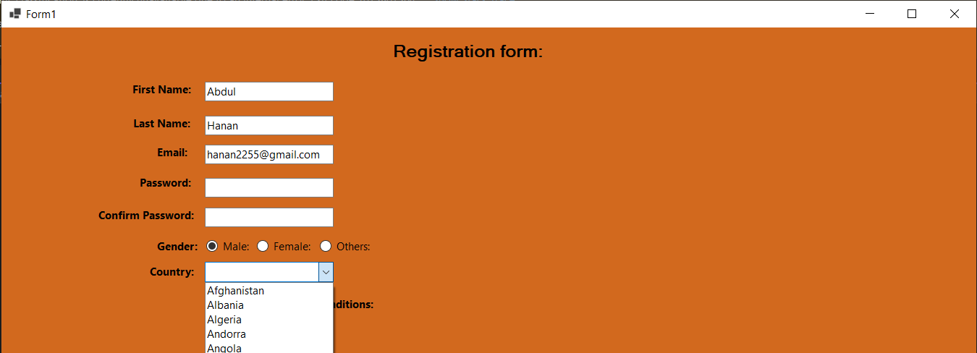

**Task no 3:**

1. Create an event handler for the "Register" button.
2. Implement the following validation checks in the event handler:
   1. Ensure that all fields are filled out.
   2. Check if the "Password" and "Confirm Password" fields match.
   3. Ensure that the user has accepted the Terms and Conditions.
   4. Display specific error messages for each validation failure.
3. If all validations pass, create a user registration summary (concatenating user inputs) and display it in a MessageBox

**Screen Shot:**

